**Experiment-3**

Study of a Non-Catalytic Gas-Solid Reaction by Thermo Gravimetric Technique

*18CH10071, Anshuman Agrawal*

**Objectives**

1. To determine conversion and reaction rate constant for the decomposition of sodium bicarbonate pellets
2. To calculate activation energy in the temperature range of 100 – 200 oC

**Theory**

Reaction under consideration:

2NaHCO3 → Na2CO3 + CO2 + H2O

The unreacted core model is applied for the analysis of the above reaction. It has been seen to satisfy most of the non-catalytic gas-solid reactions. The reaction rate can be controlled by the resistance at the pellet surface, the diffusional resistance at the boundary layer formed and the resistance due to the product layer being formed. At low conversions, it can be concluded that both the diffusional resistances (gas film and ash film) can be neglected and reaction is mostly governed by the chemical resistance. Lievenspiel’s equation is used to convert the weight lost at any instant to weight lost per unit area of interface by introducing a dimensionless factor f that represents fractional thickness of the reacted solid at any instance. The indication of reaction completion is when f attains the value of the ratio of length to diameter (a) of cylindrical pellet.

Rate equation: $R_{0}d_{0}f=kt$

Where,

R0 = initial pellet radius (cm)

d0 = density of reactant pellet (g/ cm3)

t = reaction time (s)

k = modified rate constant

The relation between reaction conversion x and f is:

$$f=1-{(1-x)}^{1/3}$$

For a cylindrical pellet with a given ratio of length/ diameter, reaction conversion is given by:

$$x=1-\frac{(a-f){(1-f)}^{2}}{a}$$

Therefore, for any x we can find f from the above equation and then calculate $R_{0}d_{0}f$ for each time instance t. $R_{0}d_{0}f$ vs t will give a straight line for chemical resistance control. At different temperatures we can plot different lines to get different values of k and then to find activation energy by plotting ln k vs 1/T.

**Schematic**

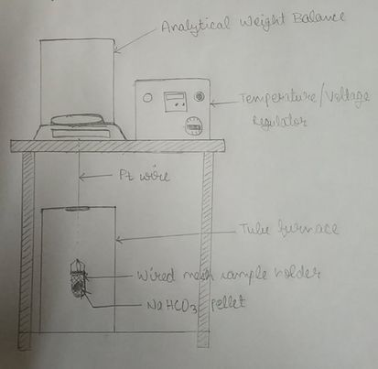

**Observations and Calculations**

Initial pellet radius = 0.9 cm (R0)

Density of pellet = 2.2 g/ cm3 (d0)

1. **T = 120 oC, a = 0.302995**

|  |  |  |  |  |  |  |
| --- | --- | --- | --- | --- | --- | --- |
| **Time (min)** | **Weight of pellet (gm)** | **ΔWeight (gm)** | **x** | **f** | **R0d0f (gm/ cm2)** | **k (gm/ cm2 min)** |
| 0 | 2.284 | 0 | 0 | 0 | 0 | 0.0021 |
| 1 | 2.273 | 0.011 | 0.0012 | 0.000226472 | 0.0004 |
| 2 | 2.213 | 0.071 | 0.0080 | 0.0015126 | 0.003 |
| 3 | 2.139 | 0.145 | 0.0163 | 0.00308891 | 0.0061 |
| 4 | 2.073 | 0.211 | 0.0237 | 0.00450036 | 0.0089 |
| 5 | 2.007 | 0.277 | 0.0312 | 0.00593678 | 0.0118 |
| 6 | 1.945 | 0.339 | 0.0381 | 0.00726358 | 0.0144 |
| 7 | 1.881 | 0.403 | 0.0453 | 0.00865353 | 0.0171 |
| 8 | 1.834 | 0.45 | 0.0506 | 0.00968029 | 0.0192 |
| 9 | 1.779 | 0.505 | 0.0568 | 0.0108853 | 0.0216 |
| 10 | 1.723 | 0.561 | 0.0631 | 0.0121141 | 0.024 |
| 11 | 1.673 | 0.611 | 0.0687 | 0.0132101 | 0.0262 |
| 12 | 1.623 | 0.661 | 0.0744 | 0.0143293 | 0.0284 |
| 13 | 1.582 | 0.702 | 0.0790 | 0.0152352 | 0.0302 |
| 14 | 1.542 | 0.742 | 0.0835 | 0.0161238 | 0.0319 |
| 15 | 1.515 | 0.769 | 0.0865 | 0.0167174 | 0.0331 |
| 16 | 1.486 | 0.798 | 0.0898 | 0.0173716 | 0.0344 |
| 17 | 1.47 | 0.814 | 0.0916 | 0.017729 | 0.0351 |
| 18 | 1.464 | 0.82 | 0.0922 | 0.0178482 | 0.0353 |

1. **T = 140 oC, a = 0.390**

|  |  |  |  |  |  |  |
| --- | --- | --- | --- | --- | --- | --- |
| **Time (min)** | **Weight of pellet (gm)** | **ΔWeight (gm)** | **x** | **f** | **R0d0f (gm/ cm2)** | **k (gm/ cm2 min)** |
| 0 | 2.659 | 0 | 0 | 0 | 0 | 0.0031 |
| 1 | 2.649 | 0.01 | 0.00107 | 0.000234512 | 0.00046433 |
| 2 | 2.585 | 0.074 | 0.00795 | 0.00174594 | 0.00345696 |
| 3 | 2.46 | 0.199 | 0.02139 | 0.00471638 | 0.00933843 |
| 4 | 2.38 | 0.279 | 0.02999 | 0.00662969 | 0.01312679 |
| 5 | 2.287 | 0.372 | 0.03998 | 0.008866479 | 0.01755563 |
| 6 | 2.197 | 0.462 | 0.04966 | 0.0110436 | 0.02186633 |
| 7 | 2.118 | 0.541 | 0.05815 | 0.0129652 | 0.0256711 |
| 8 | 2.049 | 0.61 | 0.06556 | 0.0146507 | 0.02900839 |
| 9 | 1.973 | 0.686 | 0.07373 | 0.0165181 | 0.03270584 |
| 10 | 1.92 | 0.739 | 0.07943 | 0.0178267 | 0.03529687 |
| 11 | 1.864 | 0.795 | 0.08545 | 0.0192139 | 0.03804352 |
| 12 | 1.813 | 0.846 | 0.09093 | 0.0204813 | 0.04055297 |
| 13 | 1.775 | 0.884 | 0.09501 | 0.0214278 | 0.04242704 |
| 14 | 1.738 | 0.921 | 0.09899 | 0.0223535 | 0.04425993 |
| 15 | 1.72 | 0.939 | 0.10092 | 0.0228032 | 0.04515034 |
| 16 | 1.712 | 0.947 | 0.10178 | 0.0230038 | 0.04554752 |

1. **T = 160 oC, a = 0.290**

|  |  |  |  |  |  |  |
| --- | --- | --- | --- | --- | --- | --- |
| **Time (min)** | **Weight of pellet (gm)** | **ΔWeight (gm)** | **x** | **f** | **R0d0f (gm/ cm2)** | **k (gm/ cm2 min)** |
| 0 | 2.196 | 0 | 0 | 0 | 0 | 0.0037 |
| 1 | 2.166 | 0.03 | 0.00434 | 0.000797504 | 0.001579058 |
| 2 | 2.052 | 0.144 | 0.02083 | 0.00384462 | 0.007612348 |
| 3 | 1.954 | 0.242 | 0.03501 | 0.0064867 | 0.012843666 |
| 4 | 1.86 | 0.336 | 0.04860 | 0.00903818 | 0.017895596 |
| 5 | 1.745 | 0.451 | 0.06524 | 0.0121886 | 0.024133428 |
| 6 | 1.672 | 0.524 | 0.07580 | 0.0142032 | 0.028122336 |
| 7 | 1.587 | 0.609 | 0.08809 | 0.0165632 | 0.032795136 |
| 8 | 1.521 | 0.675 | 0.09764 | 0.0184085 | 0.03644883 |
| 9 | 1.47 | 0.726 | 0.10502 | 0.0198415 | 0.03928617 |
| 10 | 1.424 | 0.772 | 0.11167 | 0.021138 | 0.04185324 |
| 11 | 1.399 | 0.797 | 0.11529 | 0.0218459 | 0.043254882 |
| 12 | 1.394 | 0.802 | 0.11601 | 0.0219869 | 0.043534062 |
| 13 | 1.391 | 0.805 | 0.11645 | 0.0220731 | 0.043704738 |

|  |  |  |  |
| --- | --- | --- | --- |
| **Temperature T (K)** | **1/T (K-1)** | **k (gm/ cm2 min)** | **ln (k)** |
| 393 | 0.002545 | 0.0021 | -6.16582 |
| 413 | 0.002421 | 0.0031 | -5.77635 |
| 423 | 0.002364 | 0.0037 | -5.59942 |

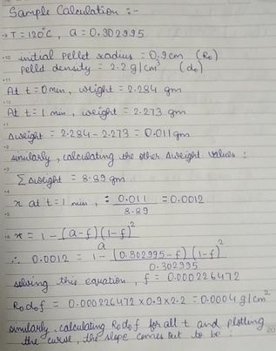

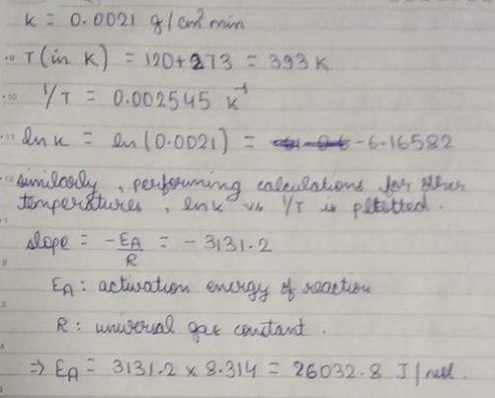

**Plots**

**Results**

The modified rate constant for various temperatures are as follows:

T = 120 oC: **0.0021 g/ cm2 min**

T = 140 oC: **0.0031 g/ cm2 min**

T = 160 oC: **0.0037 g/ cm2 min**

The activation energy for the given reaction for temperature range 100 – 200 oC is calculated to be **26032.8 J/ mol = 26.033 kJ/ mol**.

**Discussion**

1. There are 2 methods to perform thermo-gravimetric technique: in inert atmosphere (nitrogen, helium, argon) or in presence of oxygen. Here, we are using air which is more inclined towards the technique in the presence of oxygen. Proper way is to use oxygen cylinders to heat it in presence of pure oxygen therefore, some deviations in readings were inevitable.
2. Usually, vernier callipers used have a zero error present in them, therefore, it is to be noted that the zero error is taken into consideration while measuring length and diameter of the pellet.
3. Since the pellet is composed of NaHCO3, a powdered material, therefore, it is to be handled with care such that minimum particles are lost while using it. Some loss is unavoidable when we will be measuring its dimensions. During that the powder particles can break off from the pellet and result in very slight decrease in weight from the one intended.
4. The heat from the furnace is not entirely supplied to the pellet because there is also the platinum wire which can absorb some of the heat due to radiation effects. Therefore, it might take slightly less time to reach the desirable state than expected.
5. The purpose of the stainless-steel wired mesh basket is to probably absorb the heat from the furnace easily and distribute it evenly throughout the pellet medium.